**CONTAINERIZE THE APP**

|  |  |
| --- | --- |
| **Date** | 11 November 2022 |
| **Team ID** | PNT2022TMID038614 |
| **Project Name** | Smart Fashion Recommender Application |

DOCKER PUSH:

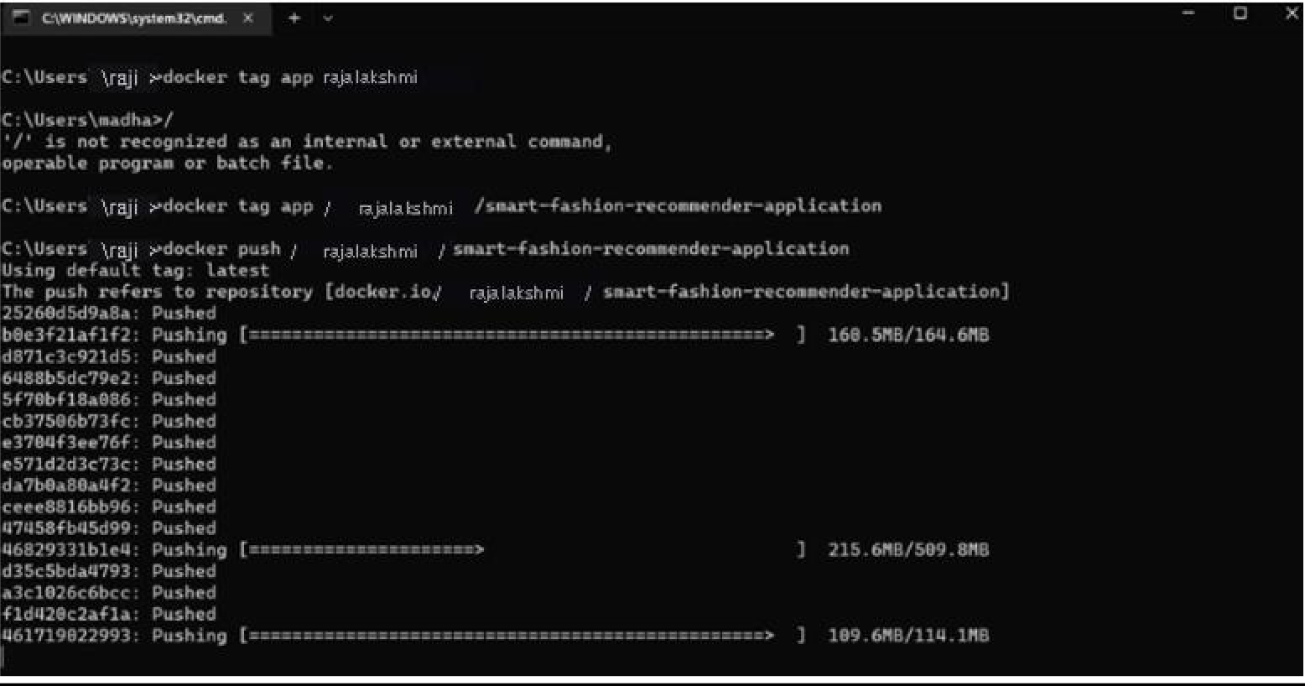

CONTAINERIZING THE APPLICATION:

